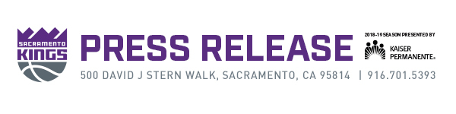
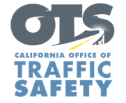

Media Contact:
Monday, October 22, 2018 Emily Mann, emann@kings.com

Kings Announce Multi-Year Partnership with
California Office of Traffic Safety

Sacramento, Calif. – Today, the Sacramento Kings and the California Office of Traffic Safety (OTS) announced a multi-year partnership to encourage fans to practice safe roadway behaviors that help them get to and from games safely.

During Kings home games and other events at Golden 1 Center, fans and guests will see a series of digital signs inside the arena and outside facing Downtown Commons promoting ways to “Go Safely.” People with the Sacramento Kings + Golden 1 Center mobile app will also receive a push notification at the end of Kings games and other events urging them to get home safely.

“Our priority is to ensure a seamless experience, which includes the journey to and from the arena,” said Sacramento Kings President of Business Operations John Rinehart. “In working together with OTS, we will promote careful commuting practices to contribute to a safer Sacramento.”

“OTS is excited to work with the Sacramento Kings, who share the same goal of making roadways safer for people looking to have a good time at games, concerts and shows at Golden 1 Center,” said OTS Director Rhonda Craft. “The event experience starts with getting there, and this partnership is another way we can let people know the importance of being safe and attentive while biking, driving or walking.”

To kick off the partnership, the Kings have launched the first of two sweepstakes for courtside seats to a Kings game. From now until Nov. 7, anyone who downloads the Kings app has a chance to win tickets for two courtside seats when the Kings play the Los Angeles Lakers Nov. 10.

For more information, visit Kings.com/Kings-App.

To learn more about OTS and their efforts to save lives through education, awareness and enforcement, visit ots.ca.gov and follow on Facebook, Twitter and Instagram.

# # #

