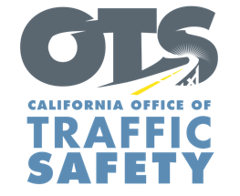
Your Agency Logo
FOR IMMEDIATE RELEASE: October #, 2018
CONTACT: [Names, Agency, phone #, email address]

[Your] Department Receives Grant for Child Passenger Safety Education and Training Program

A $________ grant from the California Office of Traffic Safety (OTS) will fund child passenger safety education and training programs aimed at helping parents and caretakers make sure their child is riding safely. The grant covers the 2019 federal fiscal year, which is Oct. 1, 2018 to Sept. 30, 2019.

Funding from OTS will go toward a variety of activities to promote occupant safety and decrease injuries and deaths due to improper use of car seats, boosters or seat belts: [Delete from or add to this list for your particular grant]
- Child seat safety check-ups/inspections
- Child safety seat education classes
- Child Passenger Safety (CPS) technician training and recertification training
- Distribute child safety seats to families in need
- Conduct safety seat usage surveys
- Promote safety seat recycling and importance of discarding used and expired car seats

[Quote from Health Director, Police Chief or other official]

A nationwide survey conducted by the National Highway Traffic Safety found that two out of three car seats are misused. Car crashes remain the leading cause of death for children, and car seats save lives by reducing the risk of injury or death.

“Children are our future and it is important that parents and caretakers keep children safe by using the right car seat, and installing it correctly,” OTS Director Rhonda Craft said. “Funding for child passenger safety education and training is critical to ensuring children are as safe as possible in vehicles.”

Funding for this child passenger safety program was provided by a grant from the California Office of Traffic Safety, through the National Highway Traffic Safety Administration.
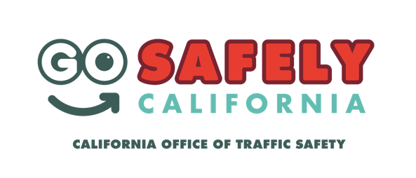

# # #

NOTE: Before filling in the names of the organization and organization spokesperson, you
MUST contact them to obtain their permission to use their names in this press release, and you
must get their approval for the language used in their quotes, and any changes or additions they
may require. Only after this is done can you send out the press release. DELETE

