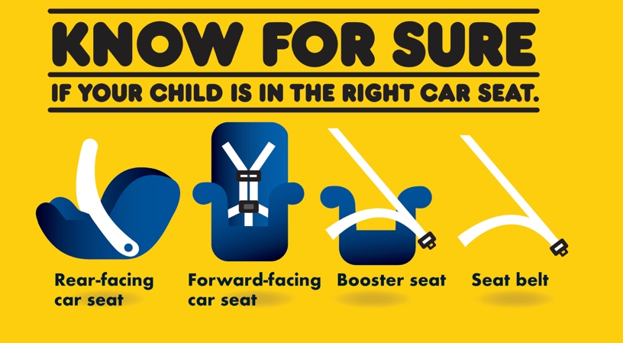

National Child Passenger Safety Week/Seat Check Up Saturday Events: Sept. 23-29

- County of San Luis Obispo Health Agency
  - Tuesday, Sept. 25, 9 a.m. to 12 p.m.
  - Target parking lot, 11990 Los Osos Valley Road, San Luis Obispo CA 93405
- CHP Sante Fe Springs
  - Tuesday, Sept. 25, 8 a.m. to 4 p.m., 10051 Orr and Day Road, Sante Fe Springs CA 90670
- CHP Antelope Valley
  - Tuesday, Sept. 25, 3 p.m. to 8 p.m., Legacy School, 930 E Avenue Q-9, Palmdale CA 93551
- CHP West Valley
  - Tuesday, Sept. 25, noon to 4 p.m., Renaldy Adult Community Center, 17450 Renaldi Street, Granada Hills CA 91344
- Contra Costa Health Services
  - Wednesday, Sept. 27 and Thursday, Sept. 28 (8 a.m. to 5 p.m. by appointment)
  - 2500 Bates Ave. Concord CA 94520
  - Call 925-532-2152 to schedule car seat safety inspection.
- Oceanside CHP
  - Thursday, Sept. 27, 8 a.m. to 3 p.m.
  - CHP Office, 435 La Tortuga, Vista CA 92084
- Redwood City CHP
  - Friday, Sept. 28, 9 a.m. to 1 p.m., Kohl’s, 250 Walnut Street, Redwood City CA 94063
- San Jose CHP
  - Friday, Sept. 28, 9 a.m. to 1 p.m., Kohl’s, 525 E. Hamilton Avenue, Campbell CA 95008
  - Saturday, Sept. 29, 9 a.m. to 1 p.m., Overfelt High School, 1835 Cunningham Avenue, San Jose CA 95122
  - Saturday, Sept. 29, 9 a.m. to 1 p.m., The Oaks Shopping Center, 21267 Stevens Creek Blvd., Cupertino CA 95014
- Yolo County Health and Human Services Agency
  - Friday, Sept. 28, 4 p.m. to 6 p.m.
  - Sutter Health Parking Lot, 2000 Sutter Place, Davis CA 95616
  - Saturday, Sept. 29, 10 a.m. to 2 p.m., Yolo County Fairgrounds, Home Arts Hall, 125 Gum Avenue, Woodland CA 95695
- San Joaquin County Public Health Services
  - Saturday, Sept. 29, 9 a.m. to 1 p.m.
  - Walmart Supercenter: 3223 E. Hammer Lane, Stockton CA 95212
- Stanislaus County Health Services Agency
  - Wednesday, Sept. 26, 1:30-3:30 p.m., 830 Scenic Drive, Modesto CA 95350
  - Saturday, Sept. 29, 9 a.m. to noon, Yancey Home Center, 1632 N Street, Newman CA 95360
- Fresno Police Department
  - Saturday, Sept. 29, 9 a.m. to 1 p.m., Valley Children’s Hospital, 9300 Valley Children’s Place, Madera CA 93636
- Pomona Police Department/SafetyBeltSafe U.S.A.
  - Saturday, Sept. 29, 10 a.m. to 2 p.m.
  - Pomona Valley Hospital Medical Center, 160 E. Artesia Street, Pomona CA 91767
- Riverside County Department of Public Health
  - Tuesday, Sept. 25, 9 a.m. to noon
  - Indio WIC, 47-923 Oasis Street, Indio CA 92201
  - Saturday, Sept. 29, 10 a.m. to 11 a.m.
  - Desert Mirage High School, 86150 66th Avenue, Thermal CA 92274
- Ventura County Health Care Agency
  - Tuesday, Sept. 25, 10 a.m. to 2 p.m.
  - Saturday, Sept. 29, 10 a.m. to 2 p.m.
  - Rio Neighborhood for Learning Family Resource Center, 3300 Cortez Street, Oxnard CA 93036
- Yuba County Health and Human Services
  - Saturday, Sept. 29, 10 a.m. to noon
  - Health and Human Services (HHSD) Packard Building, 5730 Packard Avenue, Marysville CA 95901
- Santa Cruz County Health Services Agency/CHP Santa Cruz
  - Saturday, Sept. 29, 9 a.m. to 1 p.m.
  - Dominican Hospital, 3050 Paul Sweet Road, Santa Cruz CA 95065
- Los Angeles Police Department
  - Saturday, Sept. 29, 10 a.m. to 2 p.m.
  - Constituent Services Center, 4301 S. Central Avenue, Los Angeles CA 90011
- Rancho Cucamonga CHP
  - Saturday, Sept. 29, 10 a.m. to 2 p.m., CHP Office, 9530 Pittsburgh Avenue, Rancho Cucamonga CA 91730
- Temecula CHP
  - Sunday, Sept. 30, 10 a.m. to 1 p.m., buybuy Baby, 40438 Winchester Road, Temecula CA 92591

